SALT RV pipeline tutorial

Uses Adam Distler’s RV pipeline (<https://github.com/adam-distler/SALT_RV_Pipeline>)

Follow clean_salt_rv_analysis.ipynb

SALT target files to use:

* Data uploaded as *.tar.bz2
* The relevant files are contained there. Download and extract all
* After extracting all, you should see ‘product’, ‘doc’, and ‘raw’ folders. Open the product folder
* There are a lot more files than you will need. Find the ones ending in *_uwm.fits. There should be an even number - one for redder arm and one for bluer arm for each target
  + Ex: mbgphR202506040023_uwm.fits
    - ‘mbgph’ is how all of them start
    - ‘R’ : red arm. Will be ‘H’ for the blue one
    - ‘20250604’ date in year-month-day format
    - ‘0023’ target number. May have multiple in a given day

Other files to use:

* Parsec isochrones
  + Parsec_200_1000.dat.txt
* Template Spectra
  + M type: M_p3500g4.0z0.00t1.0_a-0.20c0.00n0.00o-0.20r0.00s0.00_VIS.spec.FITS
  + G type: M_p5750g4.5z0.00t1.0_a0.00c0.00n0.00o0.00r0.00s0.00_VIS.spec.FITS
  + F type: M_p7250g4.0z0.00t1.0_a0.00c0.00n0.00o0.00r0.00s0.00_VIS.spec.FITS
    - More later on choosing between them

Now to get the RVs !

* Make sure to edit the file paths for the template and parsec file in the first cell after ‘Using the pipeline’
* In the second cell, replace the target_file with one of the SALT *_uwm.fits files that you downloaded earlier
  + My method for going through them is chronologically + by target number. Ie 5/15/25 targ 16, 18, then 20 (not real targets). It doesn’t matter how you do it though
* Just put any one of the template files to start. We don’t know a priori which one each target will use
* SALT_RV(target_file, template_file, **minwl**=4000, **maxwl**=4500, stepsize=0.05, **split**=5, rvmin=-100, rvmax=100, parsec_file=parsec_file,start=200, end=1000, step=200, nlink=2000, nburnin=1000, gwidth=40)
  + Bolded are the only things I ever change in the function. I normally leave split alone, but minwl and maxwl *have* to be changed between an ‘H’ and ‘R’ file
    - H spans ~ 3800 - 5500
    - R spans ~ 5500 - 8800

Tutorial: using mbgphR202506040023_uwm.fits & mbgphH202506040023_uwm.fits

Starting with ‘R’ here but typically i would start with H as more of the targets use the G type template

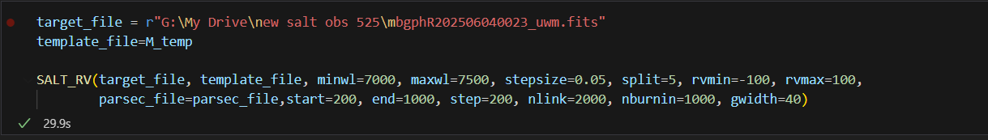

* I always use M template w red arm and G/F with blue arm. My go-to WL ranges for each are 7000-7500, 4000-4500 … but play with these as needed

The text output looks like:

Gaia DR3 5014524886749892096

INFO: Query finished. [astroquery.utils.tap.core]

RV = 11.463+/-41.322 km/s

* This tells us the GaiaId for the source + the pipeline RV. A good first check for a bad fit is the errors here … 41 km/s is massive

The image output (save these!)

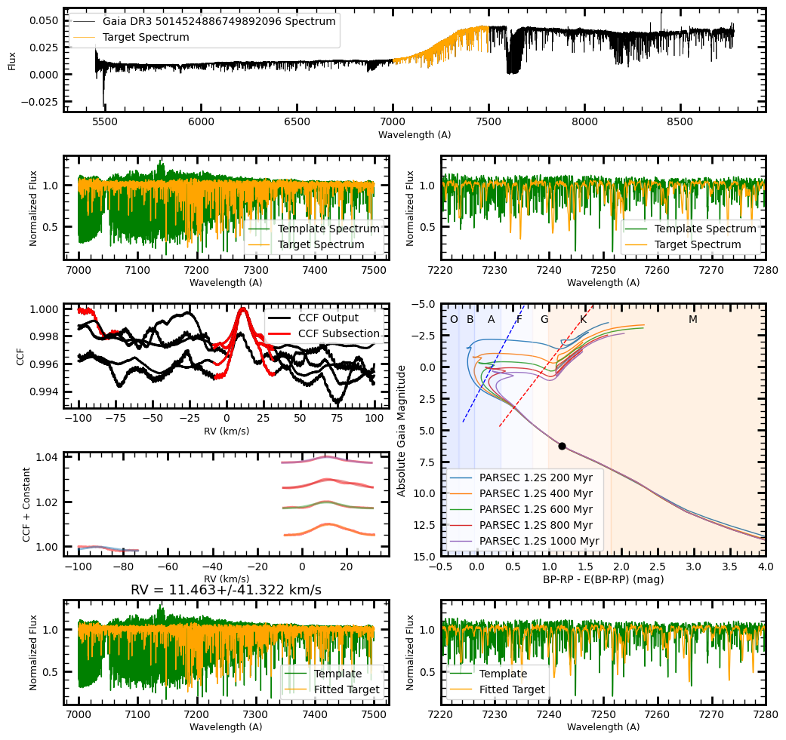

Step by step what each block shows:

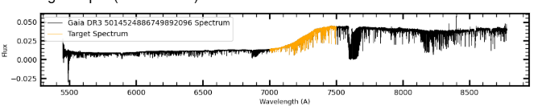

* Spectra of the target. The yellow highlight is the selected wavelength range. I use this to gauge if I need to pick a different part of the spectrum - you don’t want it to be too flat otherwise it can’t fit an RV!

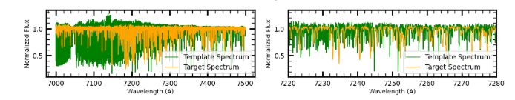

* For an rv of 0 km/s, the template (remember here I’m using the M type template and you can see that it generally doesn’t match the target spectrum here) and the spectrum itself. Left panel is the entire range, the right panel is a selected range within it.

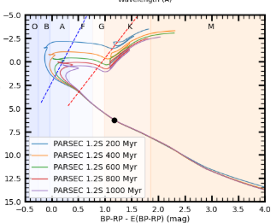

* Cmd with the source plotted on it. I use this to figure out if I need to use a new template. This star is in the K range, but much closer to a G type, so we will be going back to re-run this with the ‘H’ file and a G template. anything above G I used the F type, and for the most part i’ll use the G template with K stars unless they’re near the M dwarfs and the M template fits better

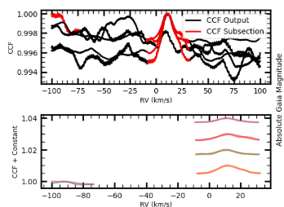

* This is how I gauge good fits. See how around 11 km/s, there are peaks that align in 4 of the 5 wavelength sections? I would guess when we use the G type template we’ll get a better fit in all sections at around that RV. sometimes it’s even messier than this and I wouldn’t be able to guess that. The M type template isn’t a great fit for this source, so it’s more difficult to cleanly determine an rv. Sometimes just changing the wavelength range helps too. I reran this source from 8000-8500 and it looks like this, which is a much better fit than the other wavelength range: 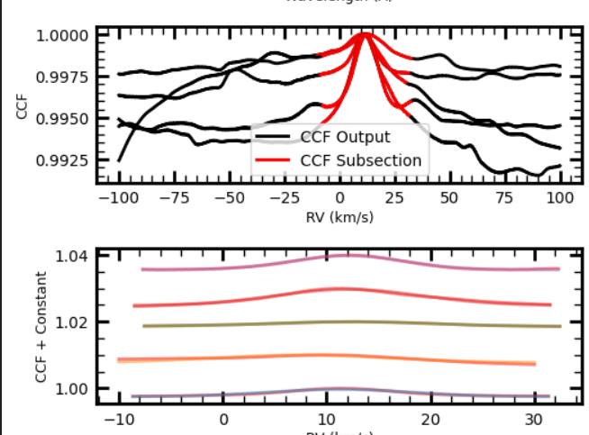

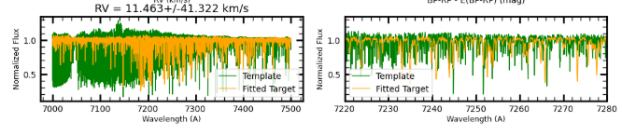

* The final panel shows the template shifted by the RV. Here's another check for a good fit - do the features in the spectra align better here than in the first panel?

Now we can re-run w a G template and the ‘H’ file: 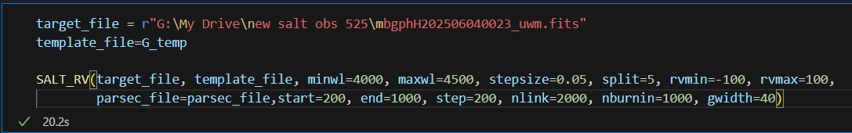

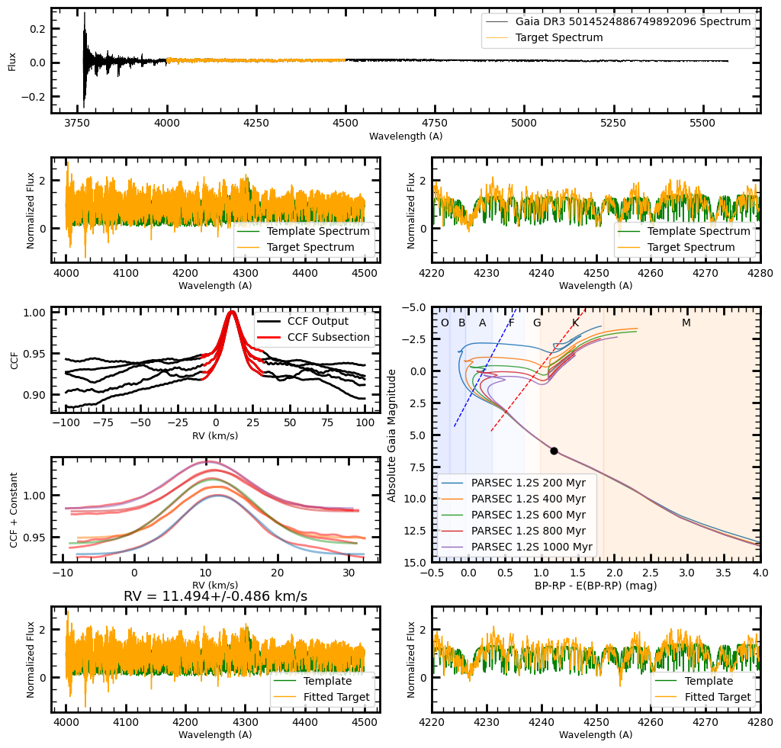

Look how clean the CCFs are! I’d call this a good fit and report this RV.

When can’t we get an RV? When no matter what you try, you just can’t get a good CCF output. The bright A and F type stars often have issues .. it didn’t matter what wavelength range this star was ran on .. the CCFs were very messy and not in agreement at all. WDs and low mass M stars are other common culprits for bad fits.

